- Using github
CREATE ACCOUNT
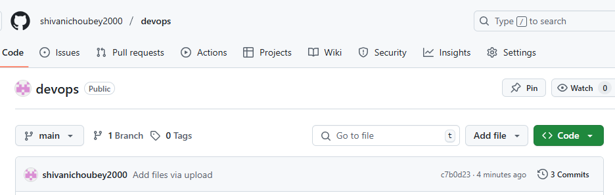
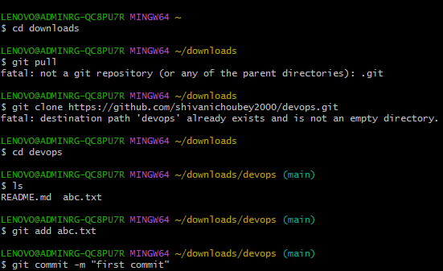
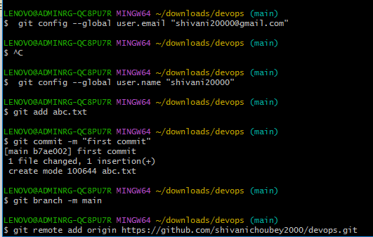
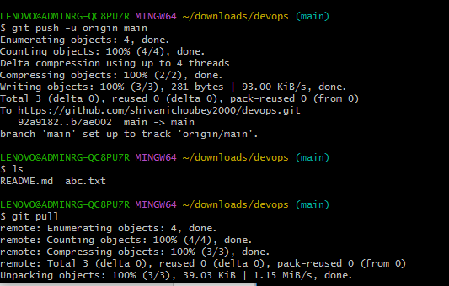
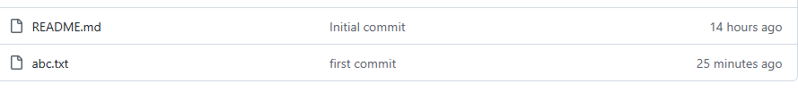

UPLOAD FILES FROM GIT
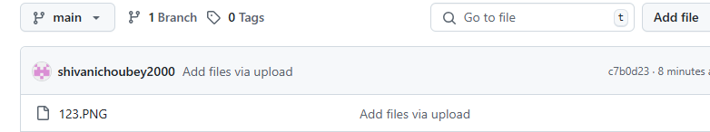
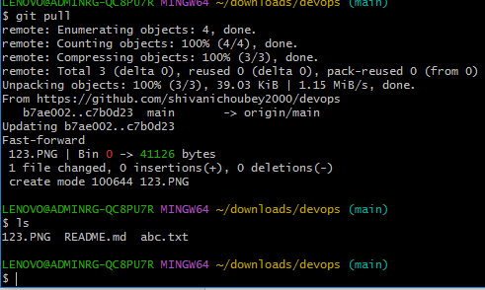

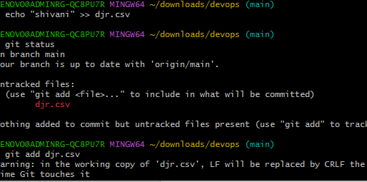

Access git using linux
Username for 'https://github.com': shivanichoubey2000
Password for 'https://shivanichoubey2000@github.com':
remote: Enumerating objects: 6, done.
remote: Counting objects: 100% (6/6), done.
remote: Compressing objects: 100% (3/3), done.
remote: Total 6 (delta 0), reused 3 (delta 0), pack-reused 0 (from 0)
Receiving objects: 100% (6/6), done.
[root@ip-172-31-83-103 ec2-user]# cd dev
[root@ip-172-31-83-103 dev]# ls
README.md pqr.txt
[root@ip-172-31-83-103 dev]# vi abc1.txt
[root@ip-172-31-83-103 dev]# git status
On branch main
Your branch is up to date with 'origin/main'.

Untracked files:
(use "git add <file>..." to include in what will be committed)
abc1.txt

nothing added to commit but untracked files present (use "git add" to track)
[root@ip-172-31-83-103 dev]# git add abc1.txt
[root@ip-172-31-83-103 dev]# git commit -m "console"
[main cd17907] console
Committer: root <root@ip-172-31-83-103.ec2.internal>
Your name and email address were configured automatically based
on your username and hostname. Please check that they are accurate.
You can suppress this message by setting them explicitly. Run the
following command and follow the instructions in your editor to edit
your configuration file:

git config --global --edit

After doing this, you may fix the identity used for this commit with:

git commit --amend --reset-author

1 file changed, 1 insertion(+)
create mode 100644 abc1.txt
[root@ip-172-31-83-103 dev]# git push
Username for 'https://github.com': shivanichoubey2000
Password for 'https://shivanichoubey2000@github.com':
Enumerating objects: 4, done.
Counting objects: 100% (4/4), done.
Compressing objects: 100% (2/2), done.
Writing objects: 100% (3/3), 314 bytes | 314.00 KiB/s, done.
Total 3 (delta 0), reused 0 (delta 0), pack-reused 0 (from 0)
To https://github.com/shivanichoubey2000/dev.git
24bd67a..cd17907 main -> main
[root@ip-172-31-83-103 dev]# ls
README.md abc1.txt pqr.txt
[root@ip-172-31-83-103 dev]#

- Using bitbucket

create mode 100644 pqr.txt
[ec2-user@ip-172-31-83-103 shivani]$ git push
Password for 'https://shivani24000-admin@bitbucket.org':
Enumerating objects: 3, done.
Counting objects: 100% (3/3), done.
Compressing objects: 100% (2/2), done.
Writing objects: 100% (2/2), 275 bytes | 275.00 KiB/s, done.
Total 2 (delta 1), reused 0 (delta 0), pack-reused 0 (from 0)
remote:
remote: Create pull request for feature/feature12:
remote: https://bitbucket.org/shivani24000/shivani/pull-requests/new?source=feature/feature12&t=1
remote:
To https://bitbucket.org/shivani24000/shivani.git
b1f63e9..e2d373b feature/feature12 -> feature/feature12
[ec2-user@ip-172-31-83-103 shivani]$
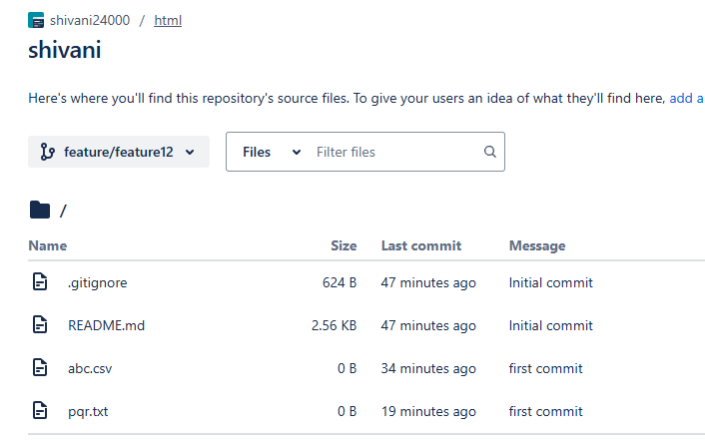

LENOVO@ADMINRG-QC8PU7R MINGW64 ~/downloads/devops (feature)
$ git branch
* feature
main

LENOVO@ADMINRG-QC8PU7R MINGW64 ~/downloads/devops (feature)
$ git branch shivani

LENOVO@ADMINRG-QC8PU7R MINGW64 ~/downloads/devops (feature)
$ git branch
* feature
main
shivani

LENOVO@ADMINRG-QC8PU7R MINGW64 ~/downloads/devops (feature)
$ git checkout shivani
Switched to branch 'shivani'

LENOVO@ADMINRG-QC8PU7R MINGW64 ~/downloads/devops (shivani)
$ git push
fatal: The current branch shivani has no upstream branch.
To push the current branch and set the remote as upstream, use

git push --set-upstream origin shivani

To have this happen automatically for branches without a tracking
upstream, see 'push.autoSetupRemote' in 'git help config'.

LENOVO@ADMINRG-QC8PU7R MINGW64 ~/downloads/devops (shivani)
$ ^C

LENOVO@ADMINRG-QC8PU7R MINGW64 ~/downloads/devops (shivani)
$ git push --set-upstream origin shivani
Total 0 (delta 0), reused 0 (delta 0), pack-reused 0 (from 0)
remote:
remote: Create a pull request for 'shivani' on GitHub by visiting:
remote: https://github.com/shivanichoubey2000/devops/pull/new/shivani
remote:
To https://github.com/shivanichoubey2000/devops.git
* [new branch] shivani -> shivani
branch 'shivani' set up to track 'origin/shivani'.

LENOVO@ADMINRG-QC8PU7R MINGW64 ~/downloads/devops (shivani)
$ git branch -a
feature
main
* shivani
remotes/origin/HEAD -> origin/main
remotes/origin/feature
remotes/origin/main
remotes/origin/shivani

LENOVO@ADMINRG-QC8PU7R MINGW64 ~/downloads/devops (shivani)
$ echo "hello world" >> abc.java

LENOVO@ADMINRG-QC8PU7R MINGW64 ~/downloads/devops (shivani)
$ git add abc.java
warning: in the working copy of 'abc.java', LF will be replaced by CRLF the next time Git touches it

LENOVO@ADMINRG-QC8PU7R MINGW64 ~/downloads/devops (shivani)
$ git commit -m "java"
[shivani adc4abb] java
1 file changed, 1 insertion(+)
create mode 100644 abc.java

LENOVO@ADMINRG-QC8PU7R MINGW64 ~/downloads/devops (shivani)
$ git push
Enumerating objects: 4, done.
Counting objects: 100% (4/4), done.
Delta compression using up to 4 threads
Compressing objects: 100% (2/2), done.
Writing objects: 100% (3/3), 269 bytes | 269.00 KiB/s, done.
Total 3 (delta 1), reused 0 (delta 0), pack-reused 0 (from 0)
remote: Resolving deltas: 100% (1/1), completed with 1 local object.
To https://github.com/shivanichoubey2000/devops.git
60172f5..adc4abb shivani -> shivani

LENOVO@ADMINRG-QC8PU7R MINGW64 ~/downloads/devops (shivani)
$ ls
123.PNG README.md abc.html abc.java abc.txt djr.csv

LENOVO@ADMINRG-QC8PU7R MINGW64 ~/downloads/devops (shivani)
$ git checkout -b branch shivani1
fatal: 'shivani1' is not a commit and a branch 'branch' cannot be created from it

LENOVO@ADMINRG-QC8PU7R MINGW64 ~/downloads/devops (shivani)
$ git checkout main
Switched to branch 'main'
Your branch is up to date with 'origin/main'.

LENOVO@ADMINRG-QC8PU7R MINGW64 ~/downloads/devops (main)
$ git checkout -b branch shivani1
fatal: 'shivani1' is not a commit and a branch 'branch' cannot be created from it

LENOVO@ADMINRG-QC8PU7R MINGW64 ~/downloads/devops (main)
$ git checkout -b shivani1
Switched to a new branch 'shivani1'

LENOVO@ADMINRG-QC8PU7R MINGW64 ~/downloads/devops (shivani1)
$ git status
On branch shivani1
nothing to commit, working tree clean

LENOVO@ADMINRG-QC8PU7R MINGW64 ~/downloads/devops (shivani1)
$ git log --all
commit adc4abb0352f4d65cc94fc8aafef8c2dcc4ca39c (origin/shivani, shivani)
Author: shivanichoubey2000 <shivanichoubey2000@gmail.com>
Date: Tue May 27 21:14:58 2025 +0530

java

commit 60172f53db0217687544b894bd0ef70487cb9d3b (origin/feature, feature)
Author: shivanichoubey2000 <shivanichoubey2000@gmail.com>
Date: Tue May 27 18:56:21 2025 +0530

html

commit 3dc0946a21efcf78307294640ca6bb5376575491 (HEAD -> shivani1, origin/main, origin/HEAD, main)
Author: shivanichoubey2000 <shivanichoubey2000@gmail.com>
Date: Tue May 27 12:17:43 2025 +0530

second commit

commit c7b0d230305e5d88c22ef4cb893fd21fcc550345
Author: shivanichoubey2000 <choubeyshivani24@gmail.com>
Date: Tue May 27 11:40:07 2025 +0530

LENOVO@ADMINRG-QC8PU7R MINGW64 ~/downloads/devops (shivani1)
$ git checkout main
Switched to branch 'main'
Your branch is up to date with 'origin/main'.

LENOVO@ADMINRG-QC8PU7R MINGW64 ~/downloads/devops (main)
$ git checkout shivani1
Switched to branch 'shivani1'

LENOVO@ADMINRG-QC8PU7R MINGW64 ~/downloads/devops (shivani1)
$ git diff shivani1 feature
diff --git a/abc.html b/abc.html
new file mode 100644
index 0000000..31e0fce
--- /dev/null
+++ b/abc.html
@@ -0,0 +1 @@
+helloworld

LENOVO@ADMINRG-QC8PU7R MINGW64 ~/downloads/devops (shivani1)
$ ls
123.PNG README.md abc.txt djr.csv

LENOVO@ADMINRG-QC8PU7R MINGW64 ~/downloads/devops (shivani1)
$ git checkout feature
Switched to branch 'feature'
Your branch is up to date with 'origin/feature'.

LENOVO@ADMINRG-QC8PU7R MINGW64 ~/downloads/devops (feature)
$ ls
123.PNG README.md abc.html abc.txt djr.csv

LENOVO@ADMINRG-QC8PU7R MINGW64 ~/downloads/devops (feature)
$ git diff feature shivani1
diff --git a/abc.html b/abc.html
deleted file mode 100644
index 31e0fce..0000000
--- a/abc.html
+++ /dev/null
@@ -1 +0,0 @@
-helloworld

LENOVO@ADMINRG-QC8PU7R MINGW64 ~/downloads/devops (feature)
$ git branch -d shivani1
Deleted branch shivani1 (was 3dc0946).

LENOVO@ADMINRG-QC8PU7R MINGW64 ~/downloads/devops (feature)
$ git branch
* feature
main
shivani

LENOVO@ADMINRG-QC8PU7R MINGW64 ~/downloads/devops (feature)
$ git branch -a
* feature
main
shivani
remotes/origin/HEAD -> origin/main
remotes/origin/feature
remotes/origin/main
remotes/origin/shivani

LENOVO@ADMINRG-QC8PU7R MINGW64 ~/downloads/devops (feature)
$
Delete branch from local and remotely gitbash
